## Prototype Application for Mapping and cataloging of Cadaster data

## Home Page

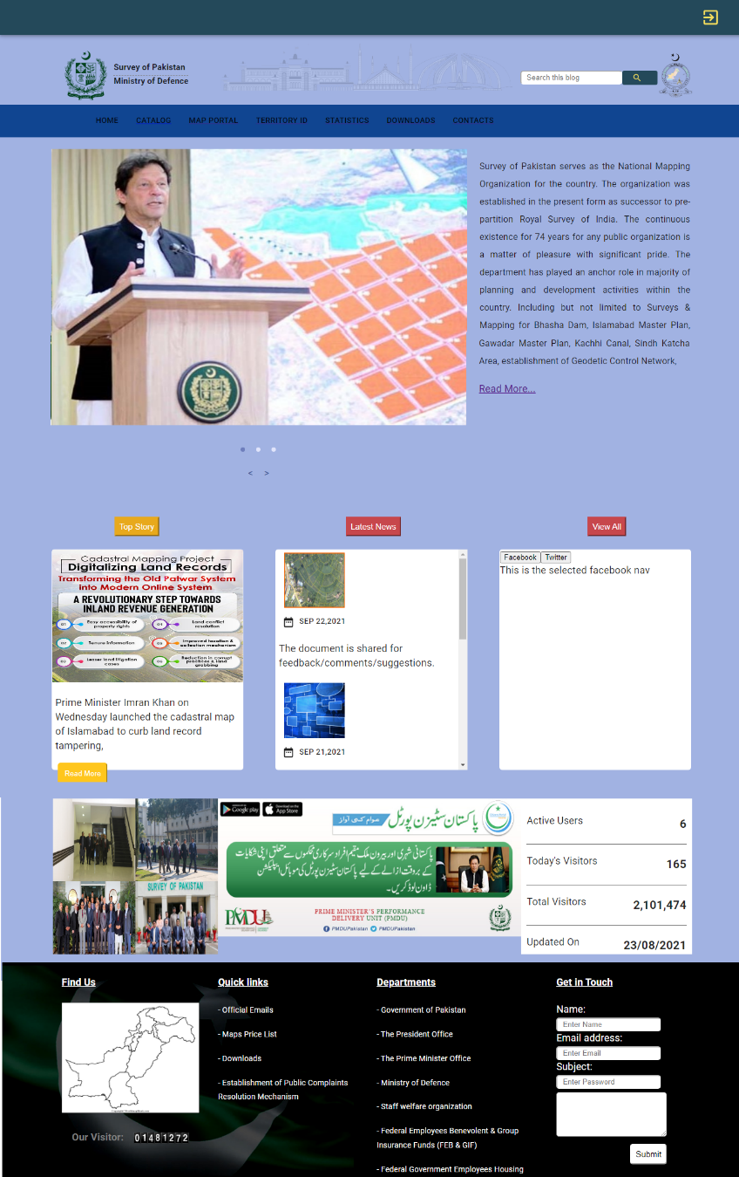

Figure 1: Application homepage

## Login page

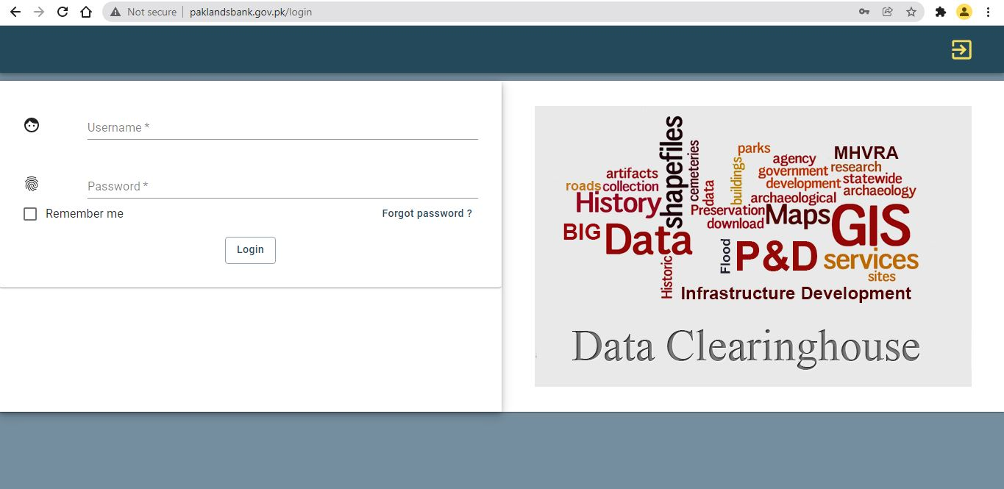

Figure 2: Application Login Page

This application is comprised of following three major modules.

* Companies Data Management
* Layer designer
* Mapping Module
* Data Analysis Module (Pivot Table)

Here is the detail of each module.

## Companies’ data management module

In company Data management module, all the companies which are working on any part of Cadaster development project (Figure 92: Company Data Management). This module will provide an interface for those companies to upload and share their data. The application has specified each company login which allows the companies to share and data uploaded. There are two mode of data sharing, Spatial data sharing (Figure 93: Spatial data upload) which include the shapefiles of relevant data and non-spatial data sharing (Figure 94: Non- Spatial Data upload) which can be of any relevant document. The user is also able to modify the display for the data uploaded according to need, thus making the application adaptable (Figure 95: Data View).

This module consists of following two parts.

## Data management for Sop Users

When a Sop user is logged in into the Data Management Module, a list of all companies data will be available as shown in figure

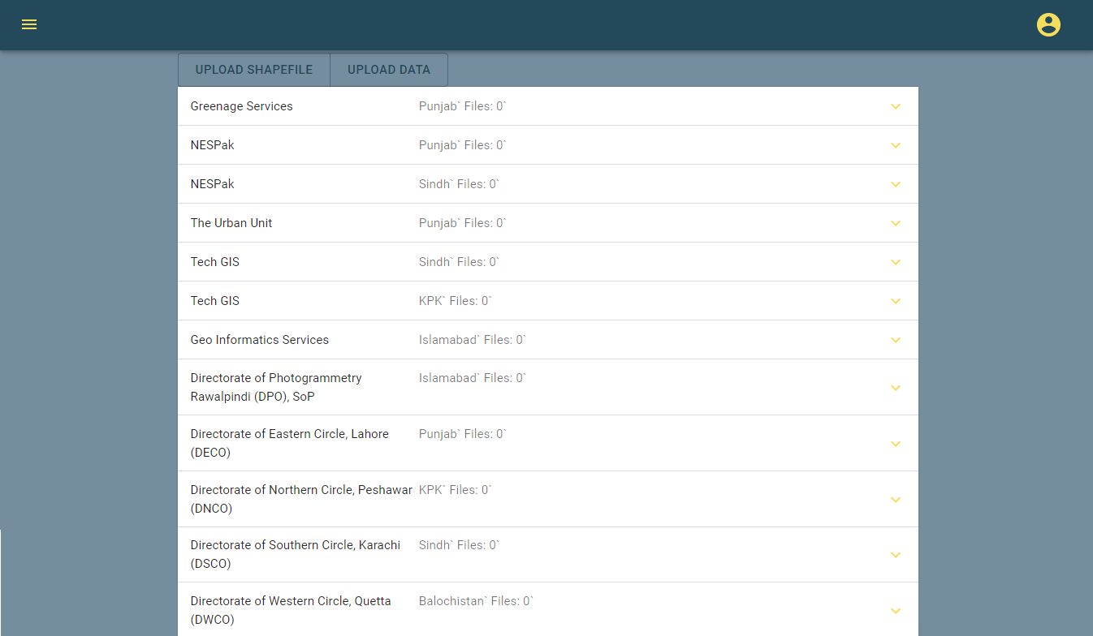

Figure 3: Company Data Management for Sop Users

SoP user can download firms’ data upload data both spatial and non-spatial, attach documents and remarks to uploaded data.

## Data management for firms

When a firm user logs into the application, then he can only view its own data. Firm user can also upload shapefiles, view shapefiles, upload raw data and upload documents as shown below.

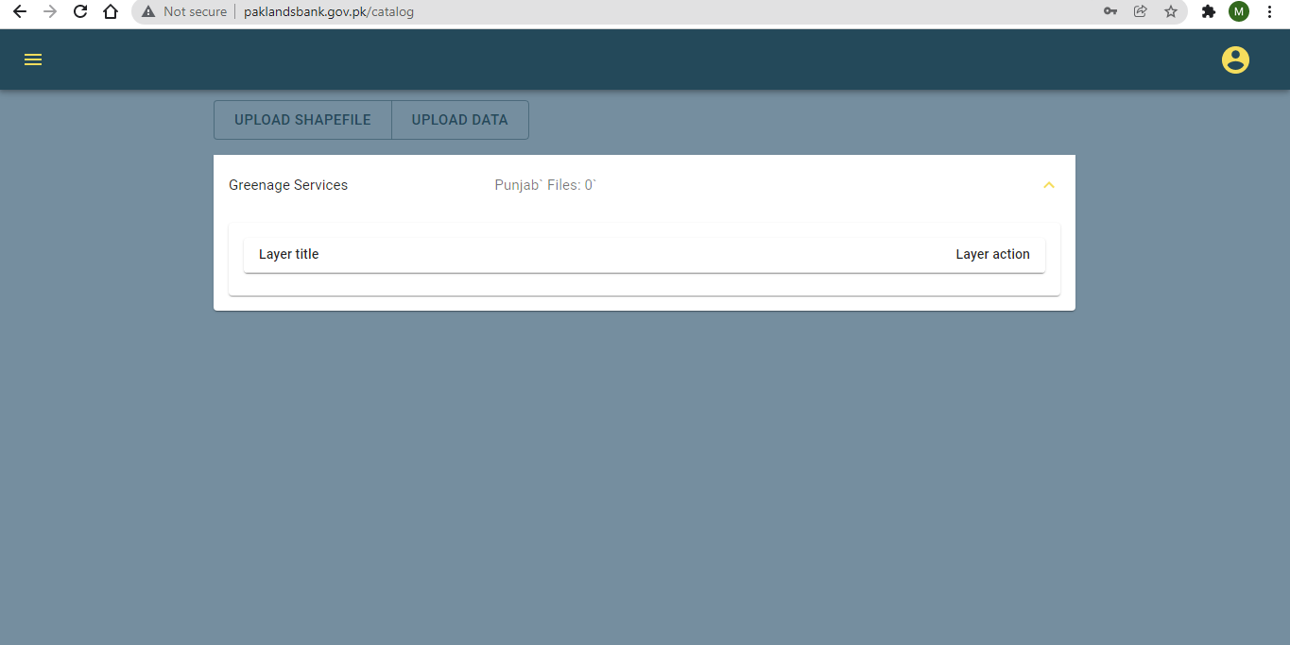

Figure 4: Data management for firms

## Upload shapefiles

Uploading of shapefiles functionality has been provided for both type of users (i.e. for SoP and firms users) as shown below.

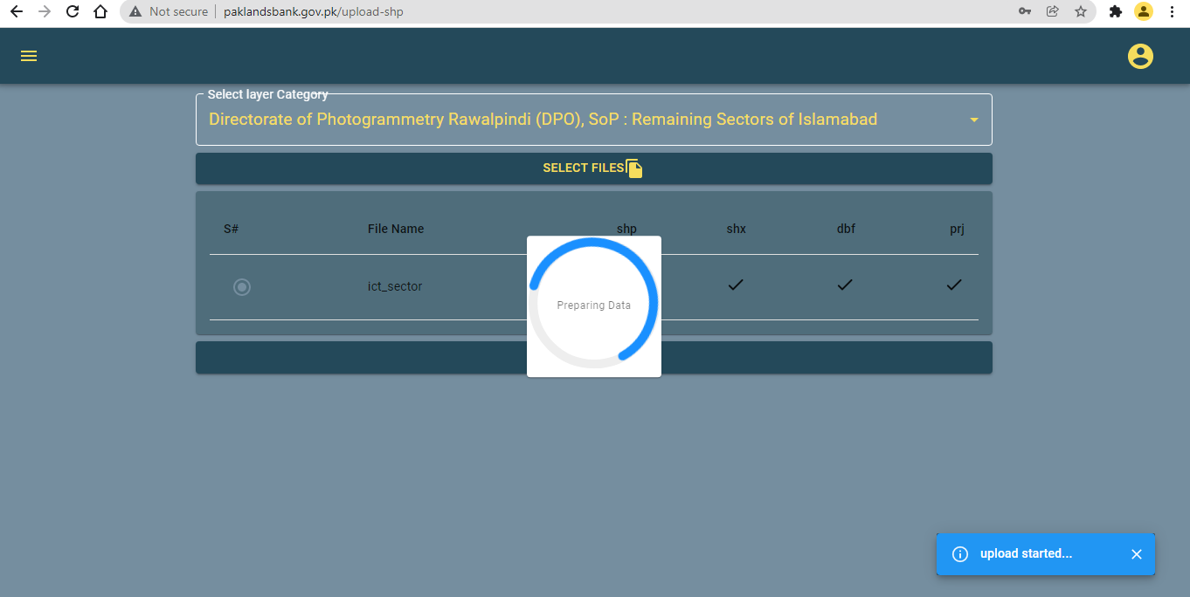

Figure 5: Upload shapefile

## Uploading of Raw Data

Uploading of raw data has been provided for all type of users. Through this functionality Sop users and firm users can upload any type of data like geodatabase, satellite images or musavies or any type of files as shown below.

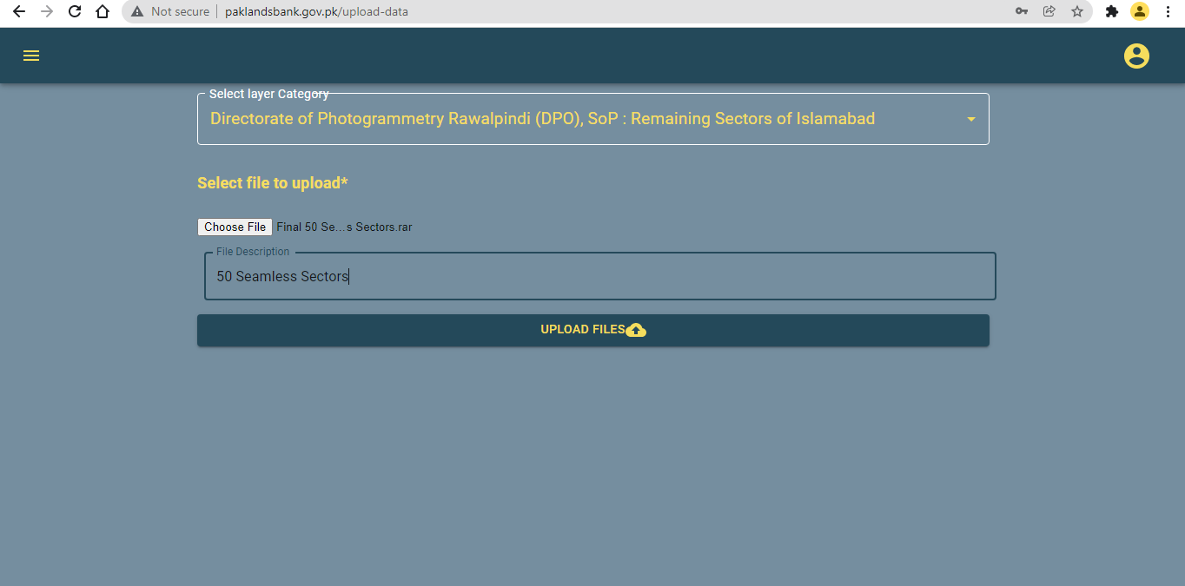

Figure 6: Uploading raw data

## Uploading documents

If any firm user uploads any data like shapefile of raw data and SoP officials download that data, examine that data and find some feature, attributes or schema to be change then they prepare a comments document and upload it against that data. Uploading of documents is also has been provided to all types of users as shown below.

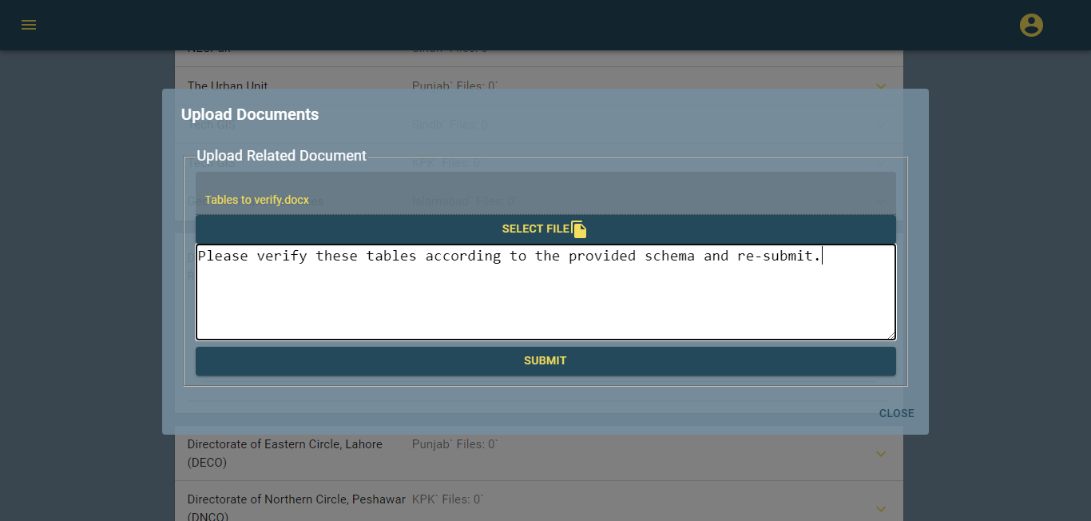

Figure 7: Upload documents.

## Data view

Using data view all users can view, upload or download spatial, non-spatial and documents as shown below.

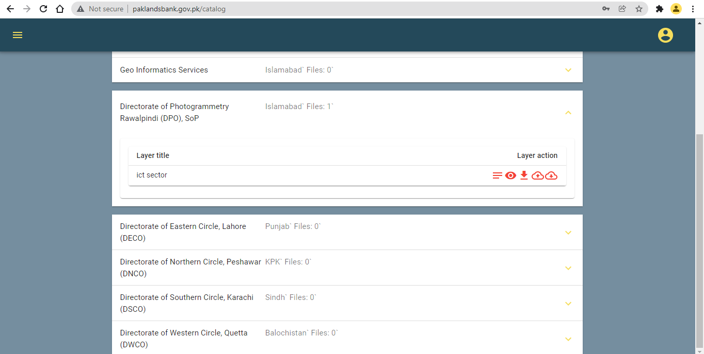

Figure 8: Data view.

## Layer designer

Layer designer has been provided to design symbology of layers (i.e. uploaded shapefiles). Using this functionality users can change default symbology, change/view metadata, upload/download documents, download layer/shapefile.

## Layer display

Layers are the mechanism used to display geographical data sets. Each layer references a dataset and specifies how that dataset is portrayed using symbols and text labels i.e. and data sharing using polygon symbology. When a layer add to a map, user can specify its dataset and set its map symbols and labelling properties. The Application allows the user to create and design their own layers by uploading the data as shown below.

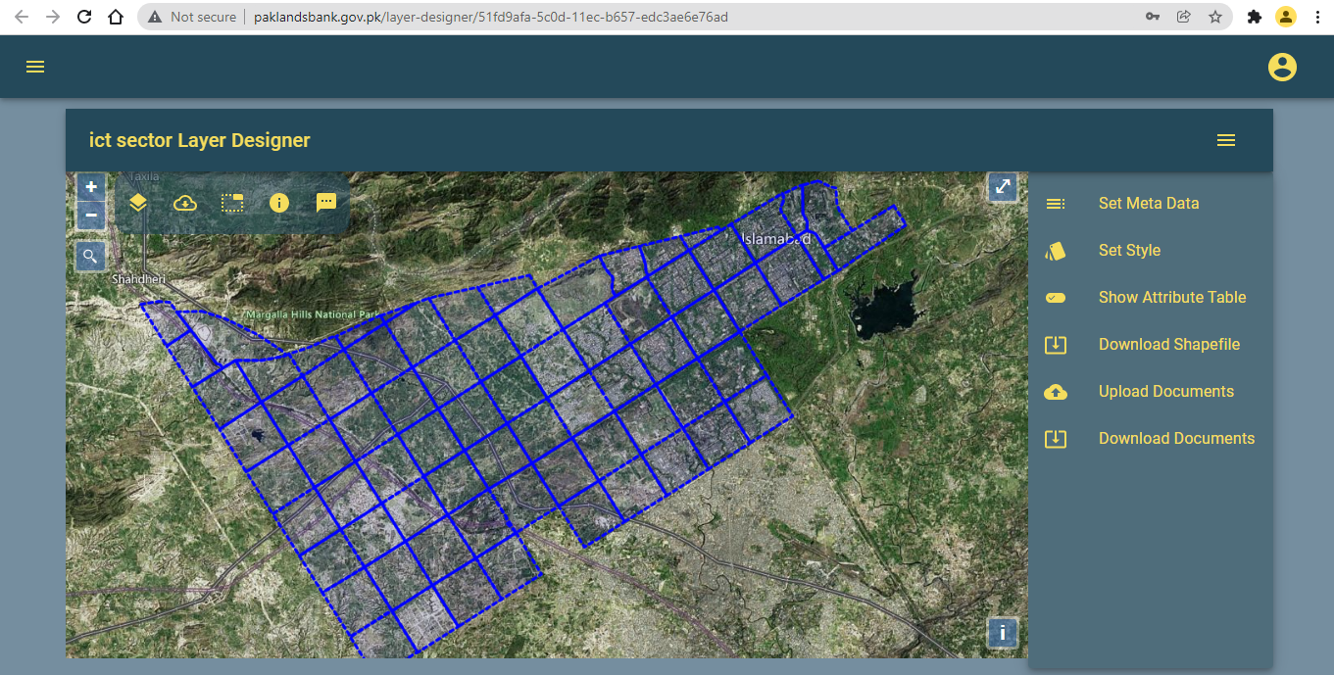

Figure 9: Layer designer

## Edit/view layer metadata

Using layer designer users can view/edit metadata of each layer by using following window.

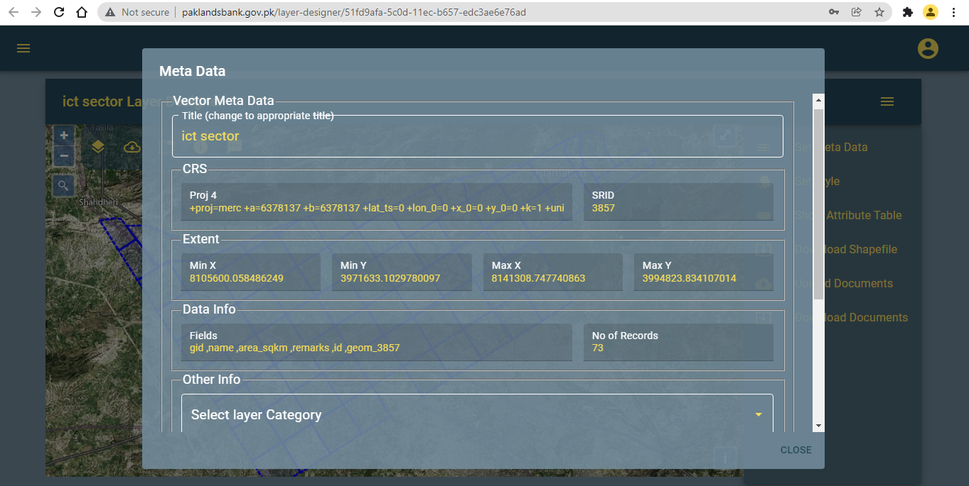

Figure 10: Edit/view layer metadata

## Design/change layer symbology

Using layer designer module users can change or re design layer symbology as shown below.

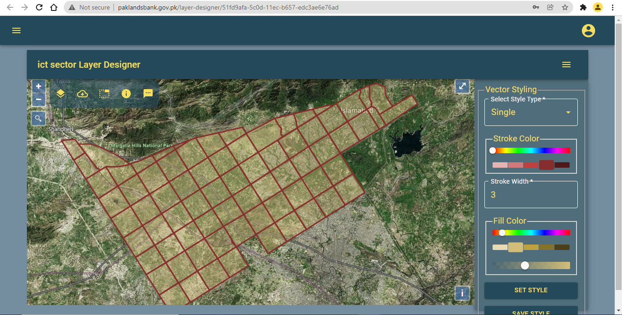

Figure 11: Changing/re-designing layer style.

## View attribute table

Layer designer has also been provided to view layer attribute table as shown below.

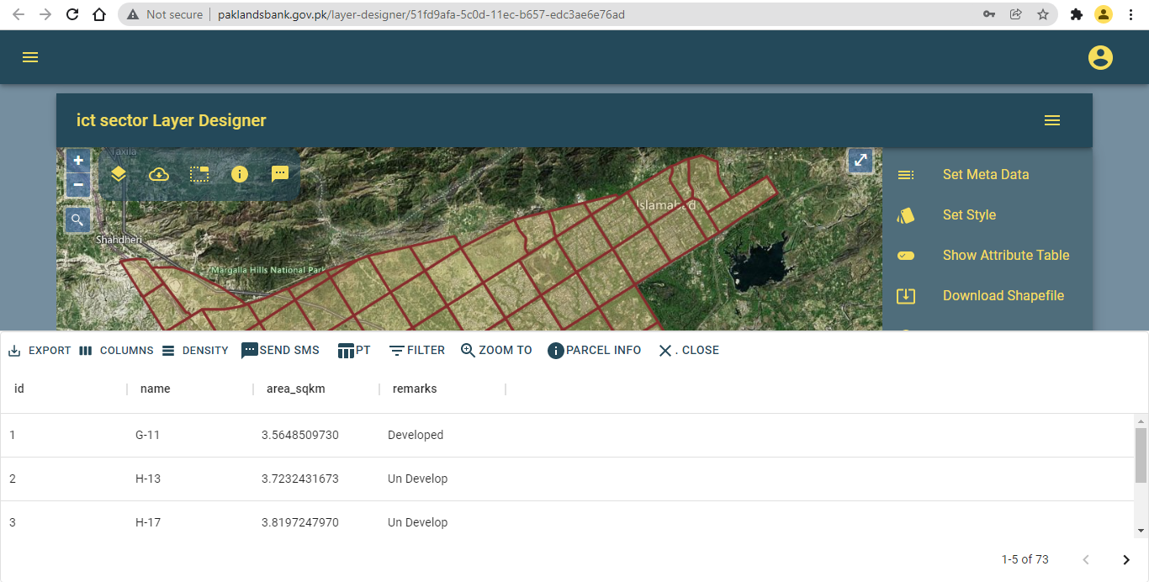

Figure 12: Layer attribute table.

## Other layer designer functionalities

Users can download layer as shapefile, upload layer related documents and download layer related documents using right-drawer of layer designer module as shown in the below figure.



Figure 13: Layer designer right drawer.

## Map module

Mapping module has been provided in this application, so that users can create maps according to their requirements, by adding one or more layers and base maps. Map modules consists of three parts.

* Table of contents (Left drawer)
* Layers catalog (Right drawer)
* Map view

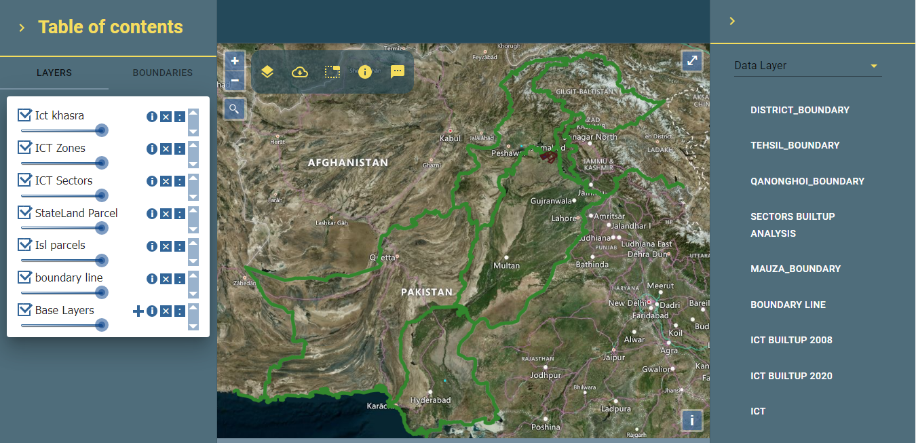

Figure 14: Map view module

## Table of contents (left drawer)

Table of contents (left drawer) is further divided into two parts i.e. layers and boundaries. Using layers tab user can on/off layers, remove layers, set transparency of layers and other layer related information. While boundaries tab can be used to navigated to administrative boundaries i.e. province -> division -> district -> tehsil -> mauza as shown below.

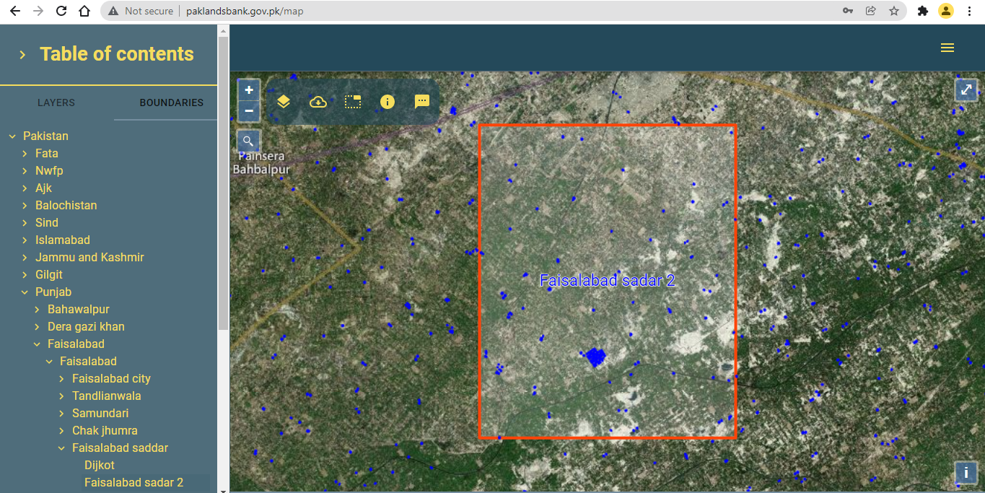

Figure 15: Admin boundaries navigation.

## Layers catalog (Right drawer)

Layers catalog is furnished with all published layers. By double-clicking on any layer from layers catalog, that layer will be added on the map and layers contents also as shown below.

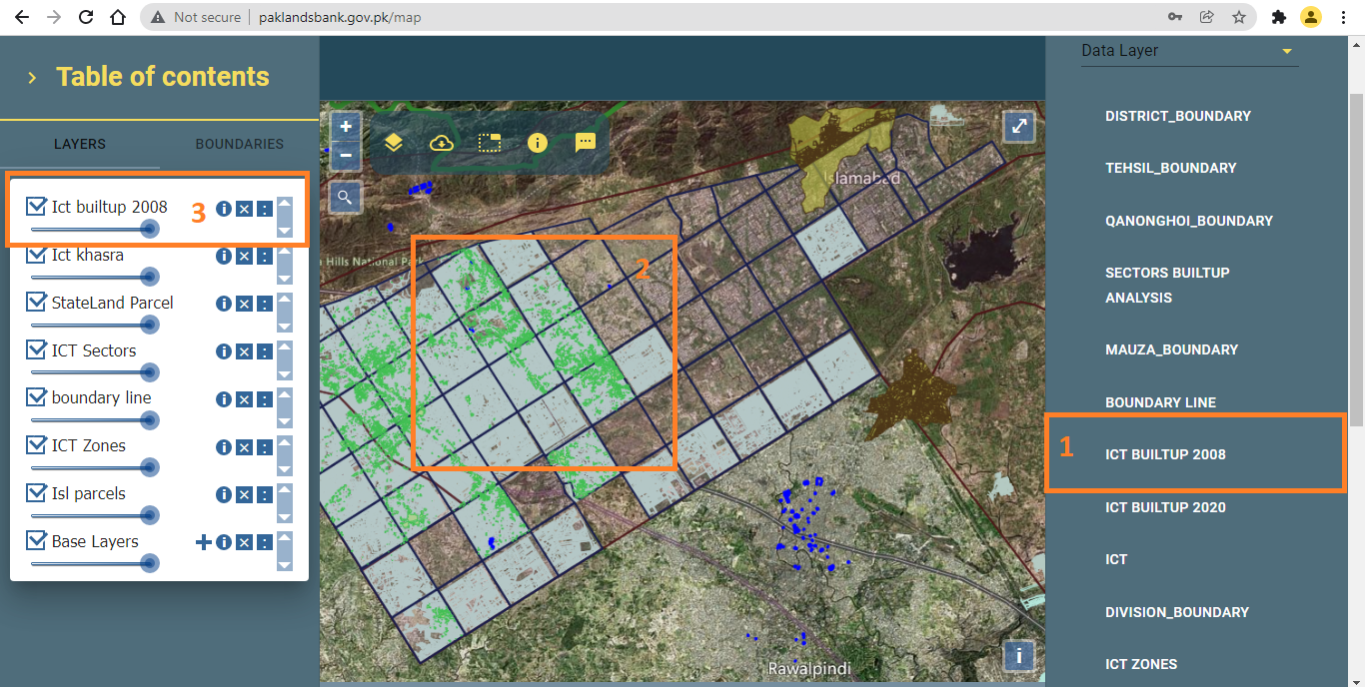

Figure 16: Layers catalog (Right drawer)

## Map view

Middle part of map module is called as map view which shows physical display of spatial data. This part is consisting of further two parts i.e. map layers and map toolbar as shown below.

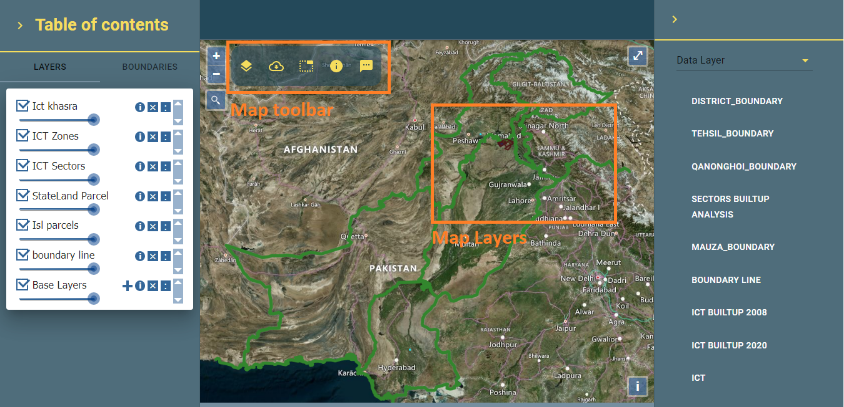

Figure 17: Map view items.

## Feature Identifier

User can identify features information using Feature identifier tool as shown below.

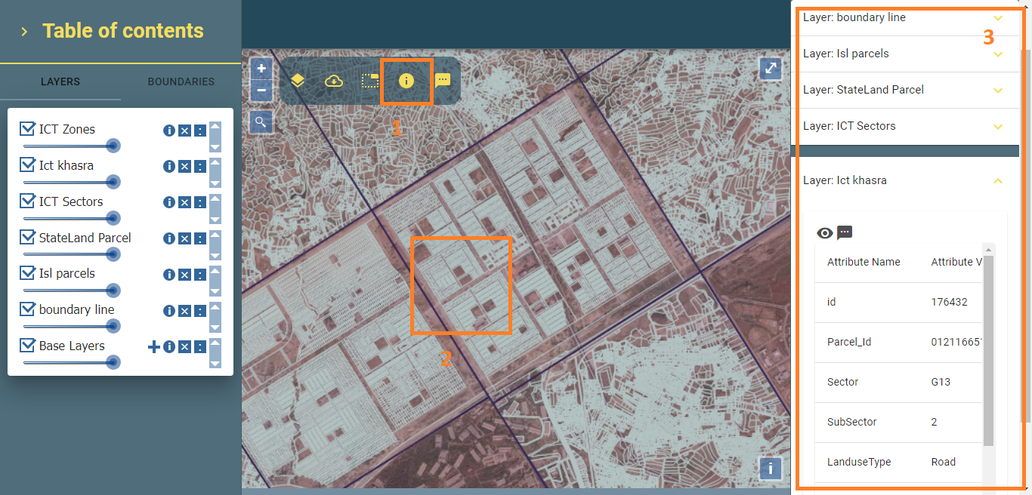

Figure 18: Feature Identifier

## Attribute Table

User can view layer attribute table by clicking on list icon provided with layer a menu list will be opened and choosing “Attribute Table” from the list as shown below.

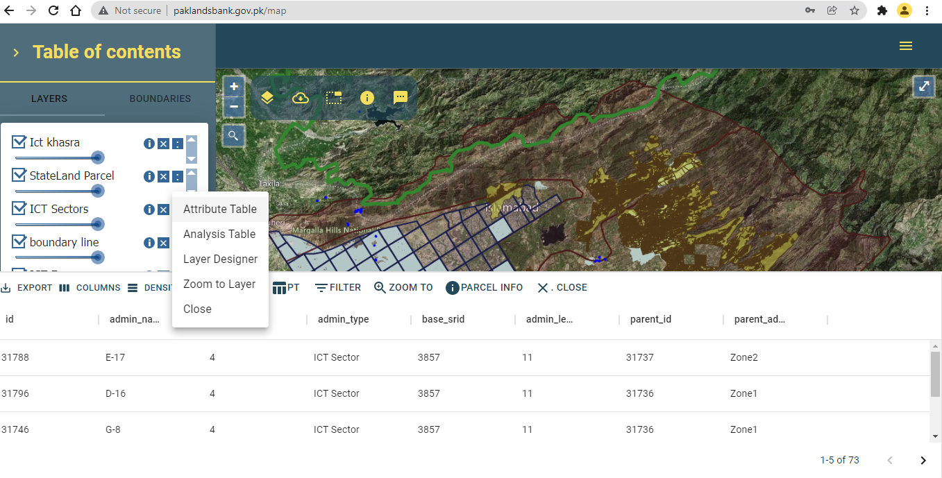

Figure 19: Layer attribute table.

## Multiple filtering on Attribute Table

Attribute table has been provided a list of tools on table toolbar, one of them is FILTER. Using this tool user can apply one or more filters at a time on attribute table as shown below.

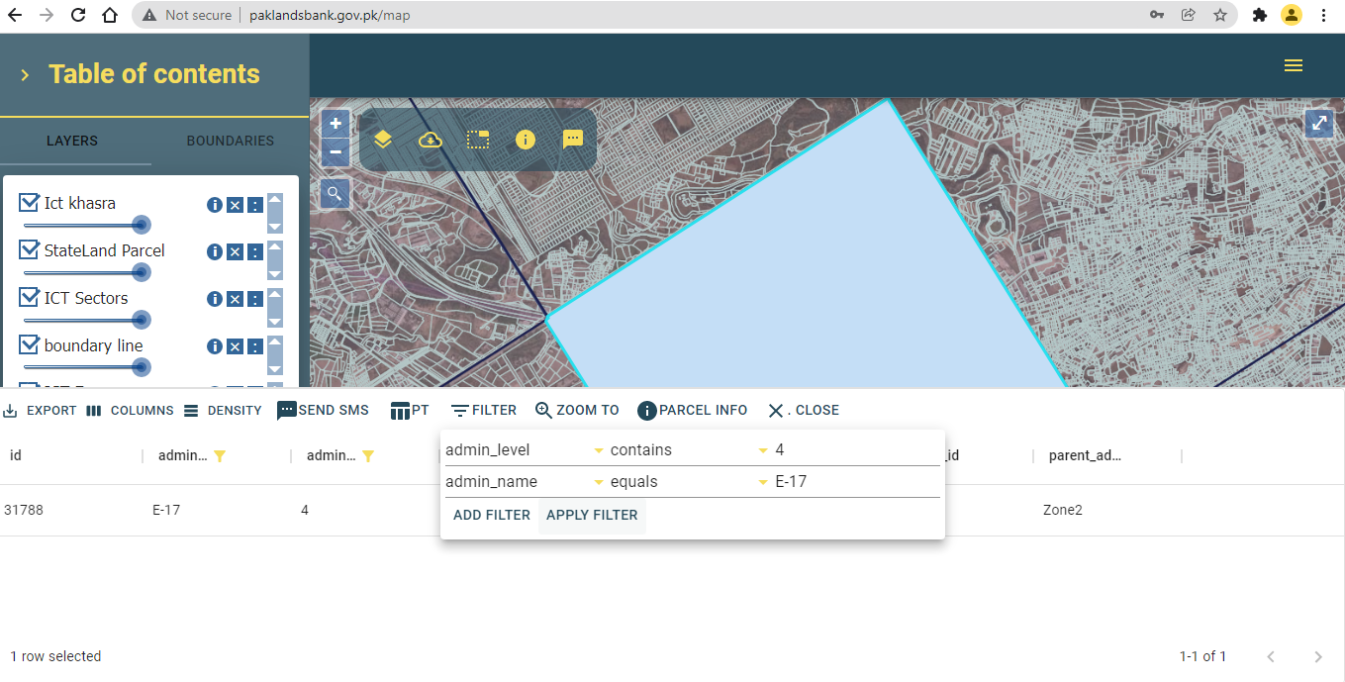

Figure 20: Multiple filtering.

SMS Utility

SMS utility has been provided with this module in three different ways as shown below.

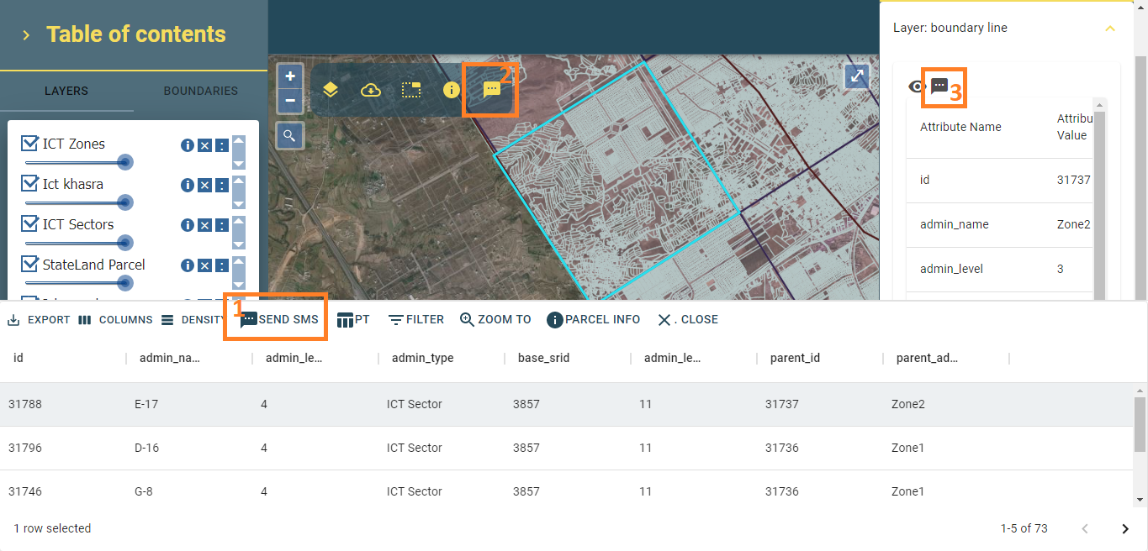

Figure 21: Send SMS tools.

User can SMS feature information to any mobile number using this functionality. User can send SMS by clicking on any one of these provided tools as shown below.

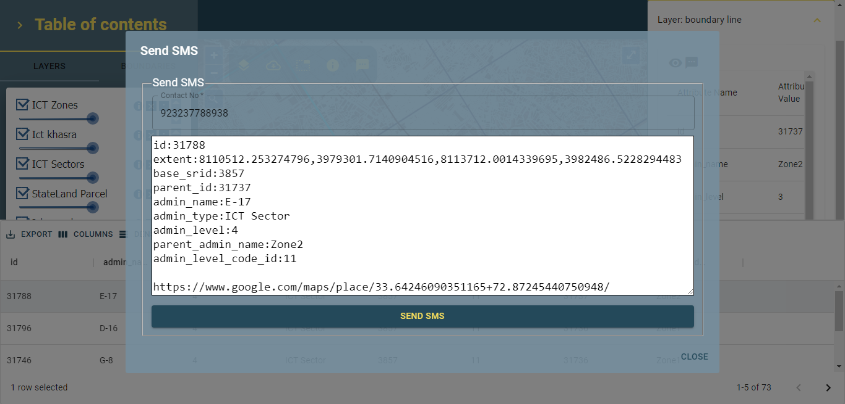

Figure 22: Send SMS form.

## Data Analysis Module (Pivot Table)

This application has been provided with a data analysis tool in which user can perform various analytical operations on each map layer by clicking on “Analysis Layer” button from table of contents. Data analysis module will be open where user can perform various analytical operations just like a pivot table. Some of pivot table analytical operations are shown below.

## Simple table

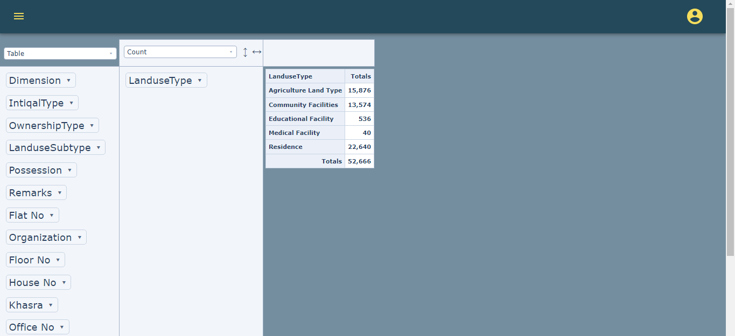

Figure 23: Simple data table

## Heatmap table using sum of attributes operation

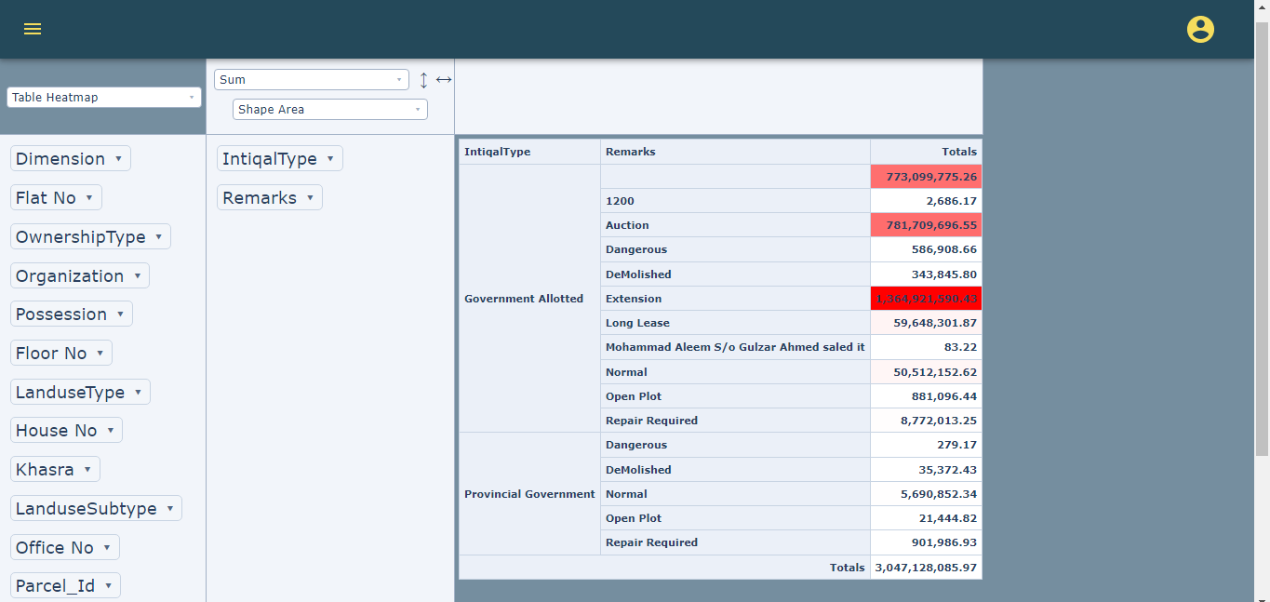

Figure 24: Heatmap Table.

## Table Column Heatmap

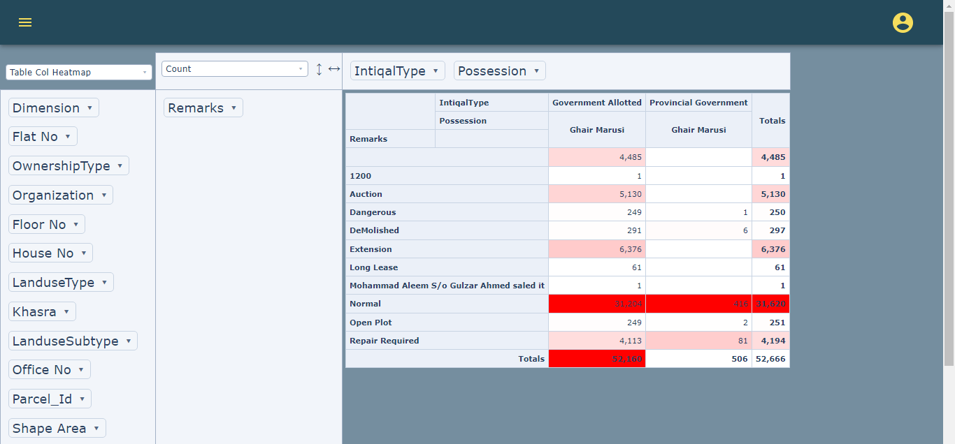

Figure 25: Table column heatmap.

## Grouped column chart

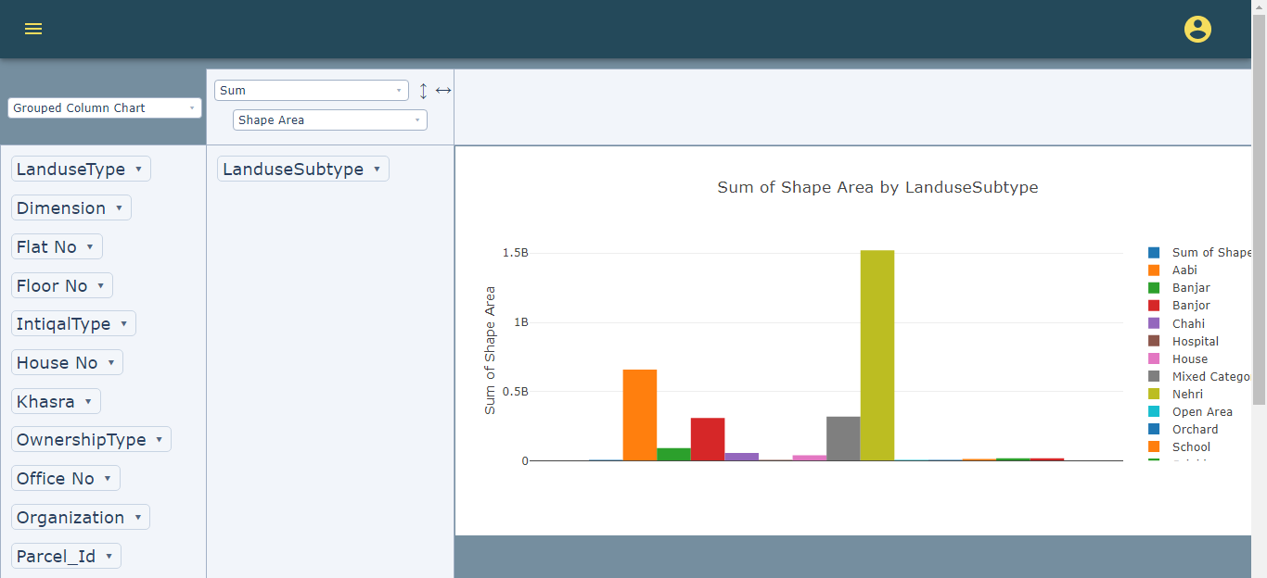

Figure 26: Grouped column chart.

Bar chart

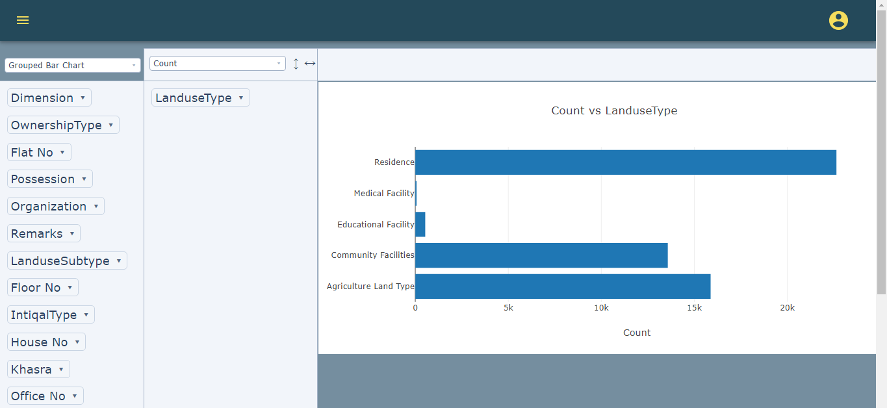

Figure 27: Bar chart.

Stacked bar chart

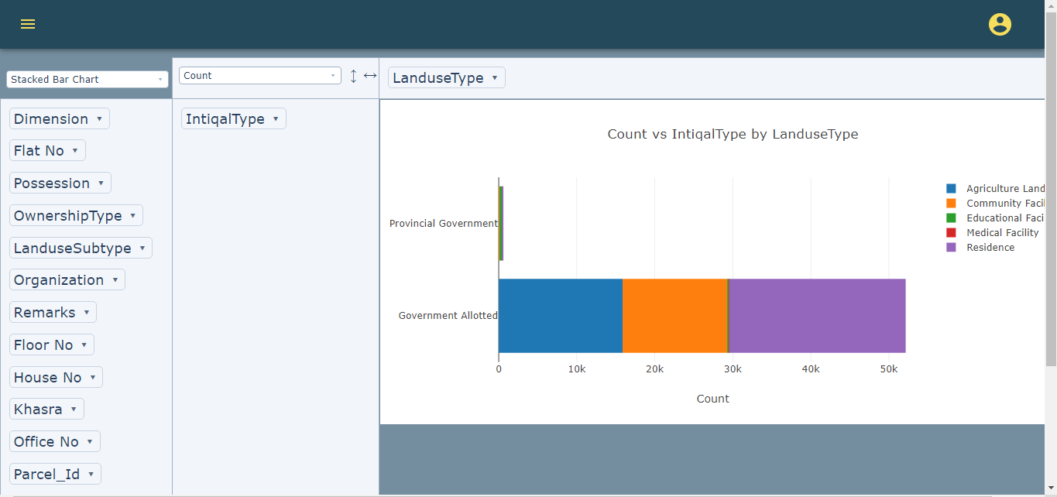

Figure 28: Stacked bar chart.

## Line chart

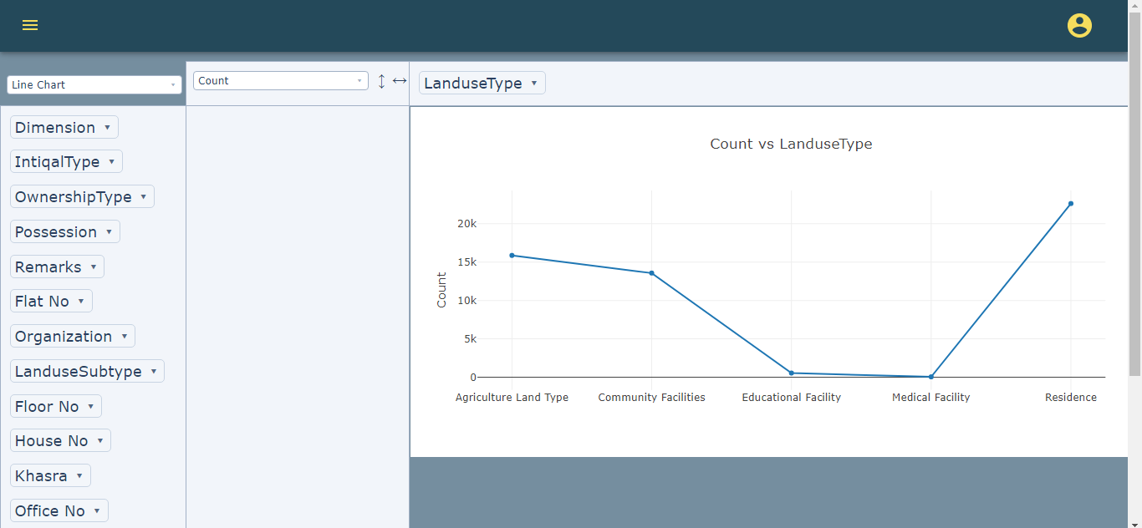

Figure 29: Line chart.

## Area Chart

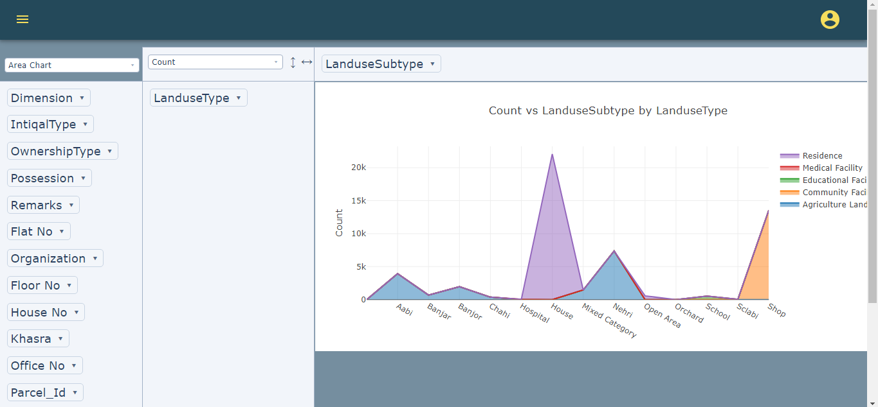

Figure 30: Area chart.

## Scatter chart

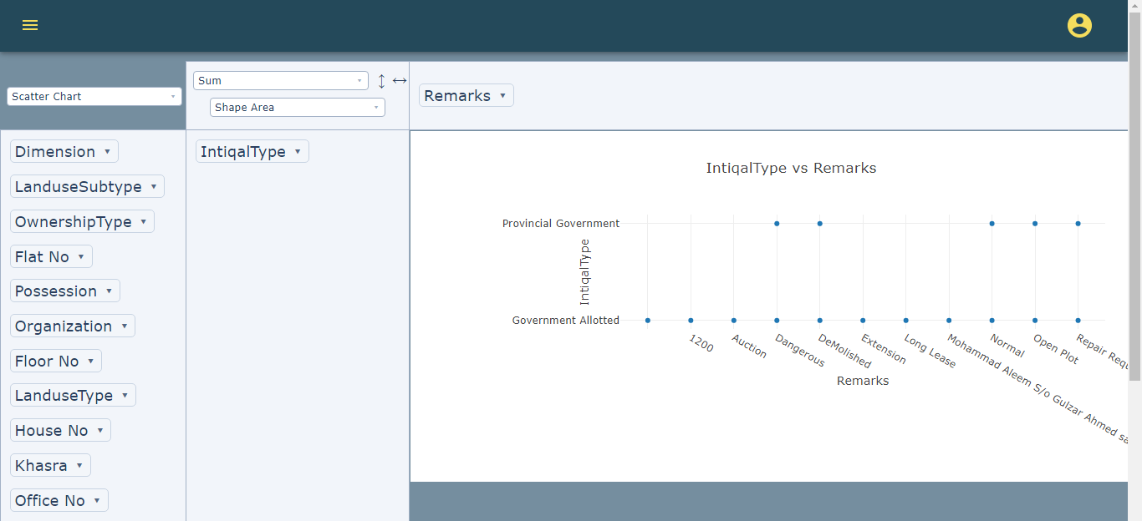

Figure 31: Scatter chart.

## Pie chart

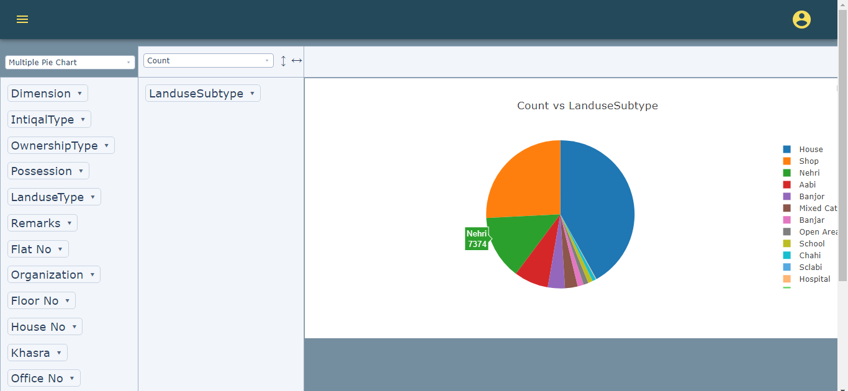

Figure 32: Pie chart.

## Multiple pie charts

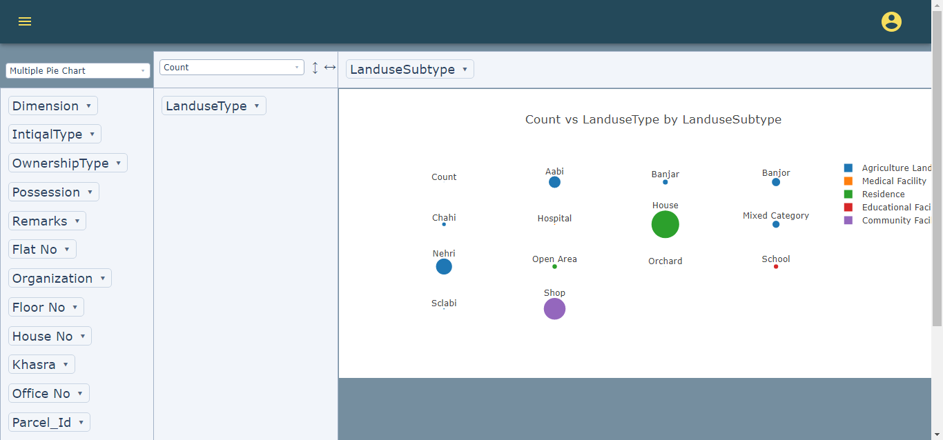

Figure 33: Multiple pie charts.